**A Smart Access Control For Restricted Buildings Using Vehicle Number plate Recognition system**

P. Madhu , P.Sai Lakshmi , T.Laxmi sri sai A.Kiran kumar.

G.Jyothsna

U.G. Students,Department of ECE, Aditya Collage of Engineering & Technology, Surampalem, A.P,India.

Senior Associate Professor, Department of ECE, Aditya Collage of Engineering & Technology, Surampalem, A.P,India.

**1 Abstract:**

Identification of incoming cars and access control to these facilities are necessary due to the rising security concerns in hotels, governmental buildings, and commercial structures. On the basis of photographs of automobiles, the platform automatically recognises licence plates. However, image-based recognition is performed when standard plates are not present. Police, backdrop, and licence plate distortion. Vehicle license plate identification is a difficult yet critical system. This is extremely useful for automating toll booths, detecting automated signal violators, and detecting traffic regulation offenders. Here, we suggest a Raspberry Pi-based car number plate recognition system that uses image processing to recognise licence plates automatically. The device makes use of an LCD display circuit connected to a Raspberry Pi and a camera. The system continuously examines incoming camera footage for indicators of license plates. When a number plate is detected in front of the camera, it analyzes the camera input and eliminates the number plate section from the image. OCR is used to process the recovered image and extract the license plate number. The extracted number is subsequently shown on an LCD display by the system. Gate will open if number plate is recognised and is in the database; else, buzzer will turn on. As a result, we proposed a Raspberry Pi-based, fully functional car number plate recognition system.

**2 Introduction:**

Licence plate recognition is a cutting-edge machine vision technology that uses licence plates to identify vehicles without the direct involvement of a person. This development of an intelligent transportation system's data on vehicle counts was utilised in our study. The License Plate Recognition (LPR) has drawn the most attention recently, and many studies are still being conducted [1]. The characters on licence plates have been the subject of numerous studies in an effort to accurately identify them. It's still early days for optical character recognition (OCR). In this article, an onboard computer, also known as the Raspberry Pi 2 CPU, is utilised. if you will, the central idea of the project. Using the current output and input modules, this onboard computer can be properly interfaced. In the United Kingdom, the Raspberry Pi Foundation developed the credit card-sized single board computer known as the Raspberry Pi. The official name of the operating system used to read a license plate on a Raspberry Pi is Raspbian JC. Functions involving recognition are carried out on the Raspberry Pi model 3. A 1.2 GHz BCM 2837 Arm Cortex CPU is built into the Raspberry Pi system on chip (SOC). A weighbridge management system based on licence plate recognition and equipped with a weight sensor is another system that is used to identify the vehicles. The mechanical control computer will activate the RFID antenna to begin reading the RFID card information when the vehicle passes the ground loop at the weighbridge's entrance using infrared sensors, ground loops, and RFID antenna [2].

If the optical character recognition software judges from the database that the license plate is registered, the gate will open automatically without human interaction. In every country, activity management and car owner identification have become critical challenges. It can be difficult to discern which automobile owner is breaking traffic restrictions and driving too fast at times. Because the activity person may not be able to obtain the car number from the moving vehicle due to the vehicle's speed, it is impossible to catch and sanction those individuals. Consequently, the development of an Automatic Number Plate Recognition (ANPR) System is required[3]. ALPR is sometimes referred to as automatic vehicle identification, optical character recognition (OCR) for automobiles, automatic number plate recognition, and car plate recognition. This paper proposes a system for reading automobile licence plates, and in the other section, related work and the proposed system's approach are explained. The suggested system's findings are then presented.In these instances, where security is crucial, the same system can be employed. There are four steps in the process of recognising a licence plate. The first one is picture acquisition, followed by licence plate extraction, segmentation, and character identification of licence plates. OCR is the method used to turn images into text. Section two provides information on the literature review, Section three defines the paper's purpose and introduces practical design and hardware implementation, and Section five defines the conclusion.

**3 Experimental:**

To construct the prototype system, various hardware components were employed, including a Raspberry Pi, pi Camera, and servos motor.

**3.1 Raspberry Pi:**

A minicomputer (Pi) was utilized to make it easier for the prototype's parts to communicate with one another. B- Pi Camera: This small camera, commonly known as a raspberry pi camera, captures the license plate number and sends it to the Raspberry Pi for analysis. The Raspberry Pi device and camera are instantly connected. When the vehicle went beneath the barrier, the Servos were utilized to control the barrier to raise up 90 degrees and then lower back down to its original position.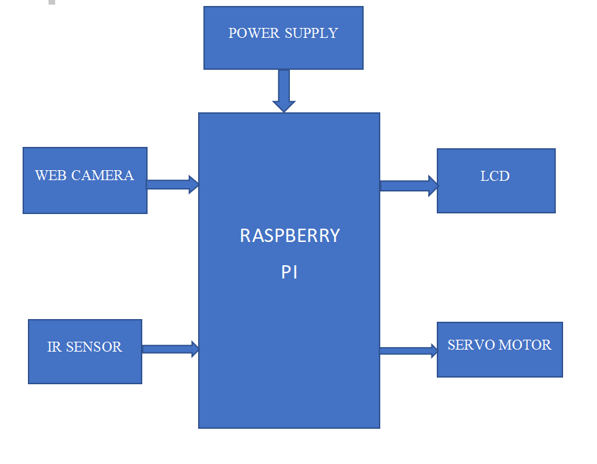

**Fig 3.1.1 Block Diagram**

**3.2 Servo Motors:**

A servo motor is a type of motor with exceptionally accurate rotational capabilities. This sort of motor often incorporates a control circuit that provides feedback on the current location of the motor shaft. This feedback enables the servo motors to rotate very precisely.

**3.3 Pi Camera:**

High resolution video and images can be captured using the Pi Camera module. We may immediately attach the PiCamera module to the CSI (Camera Serial Interface) interface on the Raspberry Pi Board. This Pi Camera module can be attached to the Raspberry Pi's CSI port using a 15-pin ribbon cable.

**3.4 System Description:**

License plate readers installed on cars are able to tell the difference between legitimate and fraudulent plates. when the car is near the barrier. A camera in front of the gate or barrier records the license plate number and sends it to the system, which checks to see if the number is already in its database. The setup controls the barrier via servos and a raspberry pi. The servos lift the barrier so that the car can pass through after the system has confirmed the license plate number and determined that entry is authorized.

The vehicle's acquired image is inputted into the pre-processing setup. The picture that was captured was shot between three and eight feet away from the car. This is designed to maintain profitable data and reduce useless data. The true number plate piece is located in the pre-processed image during the localization stage, and the localised portion is cut and used for advance processing[4].

**4 Results and Discussion:**

This project showcases an automatic license plate-based vehicle identification system. This technique makes use of OCR to identify a vehicle's license plate Because of the long shutter period, the camera utilized in this project is prone to vibration and rapidly shifting subjects. If a high-quality camera is employed, the system will run faster and last longer. Because the OCR algorithms we employ for this project are sensitive to misalignment and varying sizes, the affine transformation can be utilized to improve OCR recognition from various sizes and angles. The methods we choose might result in better results than past systems.

**5 Conclusion:**

To advance, the Automatic Vehicle License Plate Recognition system requires some suggestions. For anyone who needs to undertake a similar study, the holes that need to be filled are stated below. Missing Additional functionality: There is no functionality in this project to recognize vehicles leaving the building; it just recognizes vehicles entering the building. Install a sensor near the barrier inside the building if you wish to advance this project. When a car gets close to the sensor, this will cause the servos to lift up the barrier, letting you get out.

**6 References:**

[1] A. Katartzis and M. Petrou, "Current trends in superresolution image reconstruction," Image Fusion: Algorithms and Applications, 2008.

[2] Lin, W., & Huang, L. (2018). Design of Port Unattended Weighbridge System Based on Internet of Things. Proceedings of the 2018 3rd International Conference on Automation, Mechanical Control and Computational Engineering (AMCCE 2018). 2018 3rd International Conference on Automation, Mechanical Control and Computational Engineering (AMCCE 2018), Dalian, China. <https://doi.org/10.2991/amcce-18.2018.34>

[3] Patel, C., Shah, D., & Patel, A. (2013). Automatic number plate recognition system (anpr): A survey. International Journal of Computer Applications, 69(9).

[4] Mali, Y., Tambade, A., & Magdum, M. (2016). Artificial Neural Network Based Automatic Number Plate Recognition System. International Journal on Recent and Innovation Trends in Computing and Communication, 4(5), 4.